1. Ensure all controllers & tracker pucks are switched on and being tracked.
2. Open Live & start composer but do not select a target yet.
3. Export the camera calibration to a file called “LivConfig.cfg” next to the Scenario exe file.

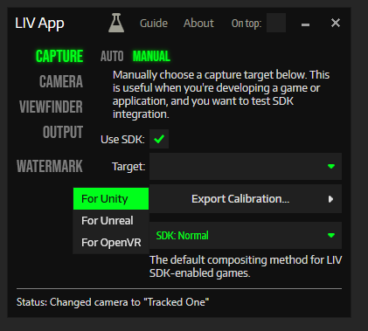

1. Open Scenario application
2. Select the scenario as a target in Liv

If output is not correct go to the camera calibration settings:

Check if there is a file called “externalcamera.cfg”, if there is delete it then change the Target in Liv and the switch back. Note this file should be there while the application is running and the Liv functionality is working normally.

If issues persist try the following:

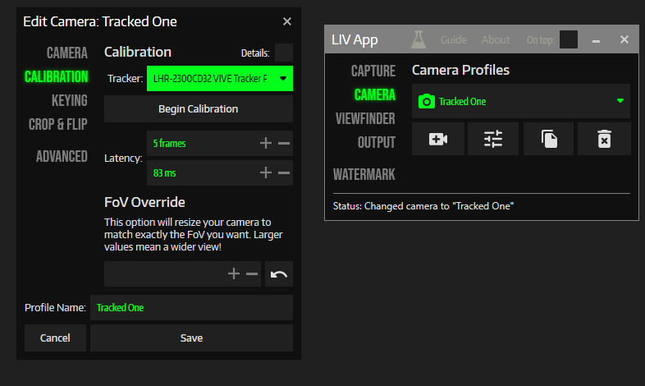

Change the tracker to one of the controllers, then save.

Check the camera is now following the controller.

Then go back to the camera calibration settings and change the tracker back to the tracking puck.